**Programming Assignment 1 Submission**

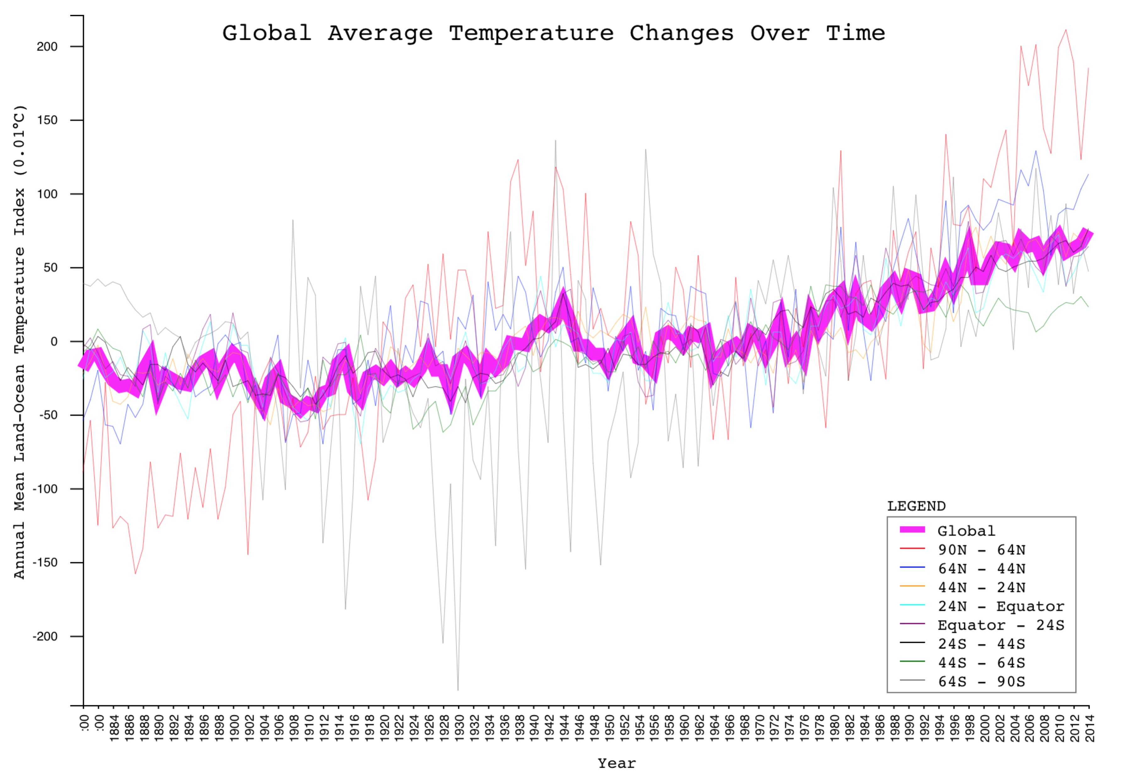

1. What are your x- and y-axes?
2. Did you use a subset of the data? If so, what was it?
3. Are there any particular aspects of your visualization to which you would like to bring attention?
4. What do you think the data and your visualization shows?

**Explanation:**

This is a line graph visualization of the data from Goddard Institute for Space Studies of global surface temperature changes over time. The data offers many levels granularity in latitude including one for the global temperature, the upper and lower hemispheres, and eventually down to 8 bands of latitudes.

This graph plots the lowest level of granularity in addition to the global series. With this many lines, it’s easy to get confused with all the intersections; consequently, I decided to use a thin stroke for each of the 8 bands of latitudes and a thick stroke for the global series. This allows me to focus on the story that this data shows: temperatures are rising over time.

In addition, there are two additional interactive features that make detail available on-demand: 1) readers can hover over a single latitude of band series in either the legend or on the line itself and the stroke width will increase ten times so it’s easy drill down to a single series of data, and 2) readers can hover over a single year and a tooltip will show the values for each band for that year.

The x-axis is a time series of years starting from 1880 and going to 2014. The y-axis is the annual mean temperature index in one one-hundredths of a degree Celsius, which is the original form of the data. This means a value of fifty in one year means that there was a .5 degree Celsius change in average temperature from the previous year.

Finally, I should note that this exercise took me over 10 hours to complete since I had to teach myself how to use d3.js. It’s an extremely powerful JavaScript library that I’m excited to learn.